Lab 11

MOSFET Diode and Triode Load
Name: Syed Sualeh Abbas, Haider Zaidi | Student ID: 10303, 10270

11.1. Objective
To design and implement a common source amplifier with MOSFET triode-load and diode-load.

11.2. Pre-Lab Task

Task 1:
- Discuss in detail the difference between discrete and integrated Circuit design using MOSFET.


11.3. Differences Between Discrete and Integrated Circuit MOSFET Design
The enhancement-mode MOSFET is the primary active device used in digital and mixed-signal integrated circuit processes. The common-source MOSFET amplifiers serve as building blocks for more complex MOSFET amplifiers. We will use CS MOSFET amplifier circuit from last lab to introduce integrated circuit design principles and application of MOSFETs to reduce chip area in integrated circuits.
One of the important differences between discrete and IC design is the selection of components to minimize chip area. A resistor or capacitor typically occupies much more chip area than a transistor. The size and number of these passive elements are limited in IC design in order to conserve chip space. Large coupling capacitors, used so freely in discrete amplifiers, are unavailable in IC amplifiers.
When MOSFET transistors are fabricated as part of an integrated circuit, practical considerations require major changes in circuit configurations, which include:
- Replacement of load resistors found in discrete amplifiers bias circuitry with active loads or current sources comprised of MOS transistors
- Fabricating direct-coupled amplifiers to avoid large coupling and bypass capacitors
Integrated circuits use both NMOS and PMOS circuitry. In MOSFET IC design, the selection of channel width is an integral part of the design procedure as the channel width determines trans-conductance and is often critical to the design of the amplifier. For this reason, channel widths may vary from a value near the minimum channel length up to a factor of hundreds or even thousands times this length.
From the perspective of integrated circuits, PSpice-based programs are imperative to demonstrate the interaction of various parameters with overall amplifier performance.

11.4. Diode Connected MOSFET
A diode connected MOSFET is a MOSFET whose gate and drain terminals are tied together. This makes 3-terminal MOS device a 2-terminal device like diode.

Task 2: To obtain characteristic curve of diode connected MOSFET
- Obtain voltage-current characteristic curve of diode connected 2N7000 NMOS in PSpice. To do this, connect the gate and drain terminals of MOSFET. Through a DC voltage source, sweep the applied voltage across drain-source from 0 to 10V with a step size of 0.1V.

- Add capture of the obtained plot.
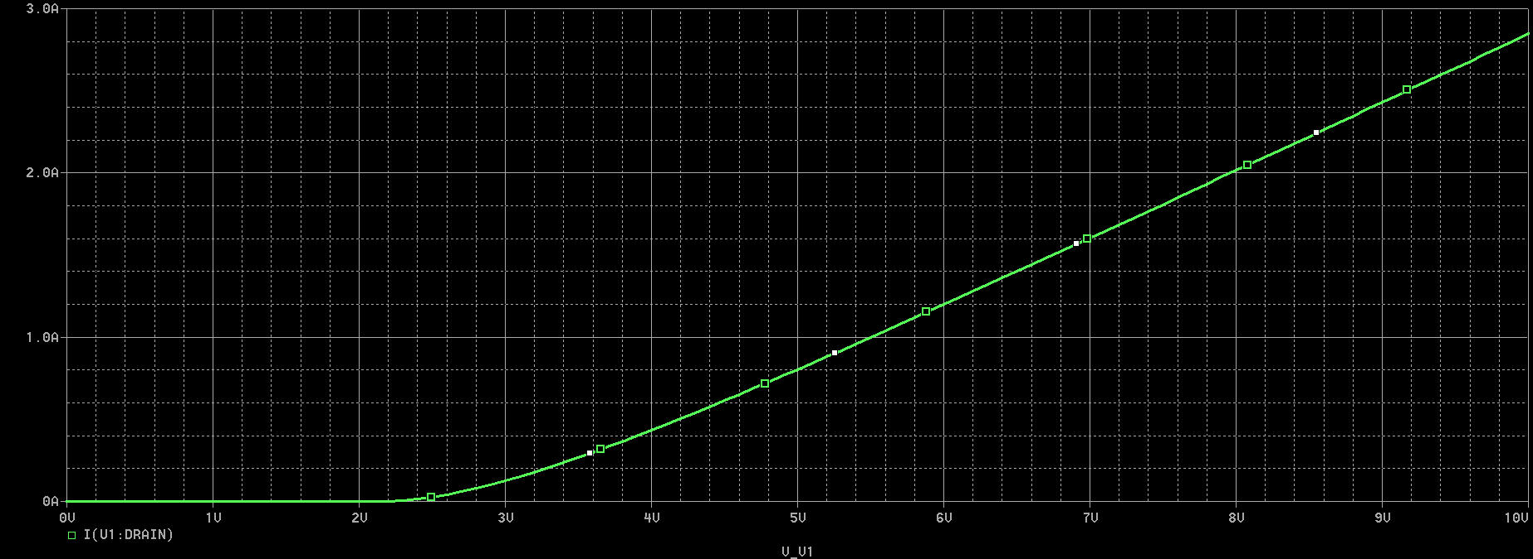
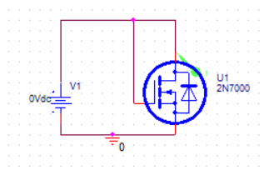
- Why do you think, this is called diode connected MOSFET? At what value of forward voltage, does the device start conduction?
It is called a diode-connected MOSFET because the gate and drain terminals are shorted together, making the device behave like a two-terminal element similar to a diode. In this configuration, the gate-to-source voltage $V_{GS}$is always equal to the drain-to-source voltage $V_{DS}$, which causes the current to increase in a manner resembling the exponential-like rise of a diode (though governed by MOSFET equations).
The device begins to conduct when the applied voltage exceeds the threshold voltage $V_{TH}$of the MOSFET. For a typical 2N7000 NMOS, conduction starts approximately around:
$$V_{DS}=V_{GS}≥2\text{V to }3\text{V}$$

- What will be the mode of operation of MOSFET in this configuration when applied voltage is greater than its threshold voltage?

When the applied voltage exceeds the threshold voltage $\left(V_{GS} > V_{TH}\right)$, the MOSFET operates in the saturation region.
This happens because:
In diode-connected configuration:
$$V_{DS}=V_{GS}$$
The saturation condition for an NMOS is:
$$V_{DS}≥V_{GS}-V_{TH}$$
Since $V_{DS}=V_{GS}$, the condition is always satisfied once the device turns ON.
Therefore, the MOSFET immediately enters and remains in saturation after conduction begins, making it behave like a voltage-controlled current source, which is why this configuration is widely used in analog integrated circuits.

11.5. Common Source Amplifier with Diode Load
In last lab, we implemented CS MOSFET amplifier (shown in Figure with resistor Rd that translates the variation in drain current (due to change in input voltage) into amplified output voltage at drain terminal. Such configuration of CS MOSFET amplifier has resistive load due to presence of resistor at drain terminal Rd.
Figure 1: CS MOSFET amplifier with resistive load implemented in Lab 10
As discussed in introduction, IC design configuration requires the replacement of resistors by other MOSFETs. The MOS transistor used as load device is called active load. CS amplifiers with diode load is such a configuration where this resistor Rd gets replaced by diode connected MOSFET.

11.6. Small Signal Analysis of CS MOSFET Amplifier with Diode Load
The small signal model of diode-connected MOSFET is shown in Figure 2. The small-signal model of the device shows that it can be replaced by an equivalent resistor ($\frac{1}{g_{m}}||r_{o})$. We will use this simplified result for small signal analysis of CS amplifier with diode-connected load.
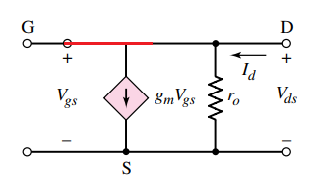
Figure 2: Small-signal model of diode connected load
The CS amplifier circuit with diode load is represented in Figure 2. Here, the biasing circuit is simplified. The two transistors are named as driver MOSFET M_{D} and load MOSFET M_{L}. The load MOSFET is diode-connected MOSFET. The equivalent small signal model of the circuit is shown in Figure 3.
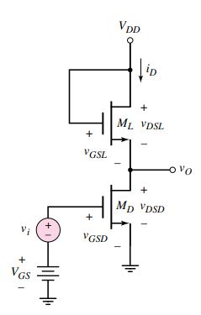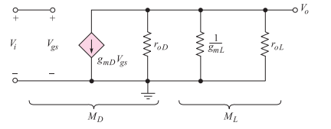
Figure 3: CS amplifier with diode connected load and its small-signal model
Using the formula for gain of CS amplifier with resistive load (from previous lab), the voltage gain of this circuit can be directly expressed by replacing Rd by the resistance of diode-connected load. Remember, r_{o} is considered to be infinite when there is negligible effect of channel length modulation.
The trans-conductance parameter is given by
When driver-MOSFET and load-MOSFET have same k_{n}’ i.e. the product of the electron mobility, μ_{n}, and the oxide capacitance, Cox, then the gain depends on aspect ratio of MOSFETs only as same drain current flows through the two MOSFETs which is the advantage of CS amplifier with diode-connected load.

Task 3: To design CS amplifier with diode-connected load
- Consider the CS amplifier circuit of Figure 1 with Rd replaced by a diode-connected load. Find the aspect ratio of load-MOSFET that makes the amplifier gain equal to 10 V/V when the process trans-conductance parameter K_{n}’ and threshold voltages of both the MOSFETs are same. (K_{n}’=0.5 and Vt=2.14 V). The aspect ratio of the driver-MOSFET is 1 (W=L=1e-4).

- Create NMOS model with the selected specifications to model load MOSFET using Mbreakn3 models with PSpice model editor.
- Implement the circuit of Figure 1 with 2N7000 as driver-MOSFET model and Rd replaced by load-MOSFET model (diode-connected).
- Perform transient analysis to obtain the input and output waveforms of amplifier. Add capture of the implemented circuit and waveforms.
- Calculate the gain of designed amplifier using results.
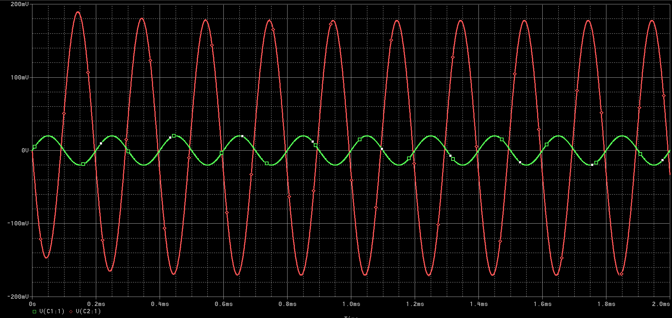
Step 1: Applying Gain Condition
$$10=\sqrt{\frac{\left(W/L)_{1}\right.}{\left(W/L)_{2}\right.}}$$
Squaring both sides:
$$100=\frac{\left(W/L)_{1}\right.}{\left(W/L)_{2}\right.}$$
Step 2: Solve for Load Aspect Ratio
$$\left(W/L2) = \frac{\left(W/L)_{1}\right.}{100} = \frac{1}{100} = 0.01\right.$$
Step 3: Determine Dimensions of Load MOSFET
Assuming the same channel length for both transistors:
$$L_{2}={10}^{-4} \\ W_{2}=(W/L)_{2}×L_{2}=0.01×{10}^{-4}={10}^{-6}$$
Calculation According to the simulation:
Input= 20mV
Output: 180mV , gain = 9 times, accuracy= 90%

11.7. Common Source Amplifier with Triode Load
Since, we know that in triode region, MOSFET acts as a voltage-controlled resistor. We can replace the drain resistor Rd in CS resistive-load amplifier (Figure 1) by a MOSFET that operates in triode-region.
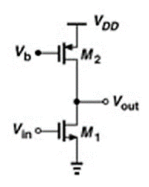
Figure 4: CS amplifier representation with M2 as triode load
This circuit needs a separate voltage supply Vb for providing the required gate voltage to the load-MOSFET. The value of this gate voltage is chosen to make the load MOSFET operate in deep triode region with the required-on resistance. For this, the condition used to make sure that the MOSFET is operating in deep triode region is given by;
To easily achieve this condition, PMOS is preferred with its source tied to supply V_{DD}. For PMOS, the voltages are negative therefore, the conditions are reversed. Instead of taking negative voltages and opposite conditions, one can simply use the following where only magnitude of threshold voltage is being considered and the voltages are measured from source to gate and source to drain terminals.
In triode region, MOSFET resistance is given by;
Moreover, for driver-MOSFET M1 has to be in saturation for amplification therefore, Vout > V_{GS}-V_{t}.

Task 4: To design CS amplifier with triode-load
- Create a model for PMOS using MbreakP3 model in PSpice. Open Model Editor window and set the threshold voltage -1V. Kn’=0.002 and W=L=100um.
- In your C amplifier circuit of Figure 1, replace the resistor Rd by this MOSFET such the the source terminal is connected with supply as shown in Figure 4.
- Connect a separate DC source for Vb at gate of this MOSFET.
- Let, Vb = -3V. Perform bias point analysis. Prove that the load MOS operates in triode region and driver MOS operates in saturation region.
Load MOSFET (PMOS): Operates in TRIODE region because Vsd = 0.316V is much smaller than Vsg - Vtp = 6V. The small drain-to-source voltage makes it act as a resistive load.
Driver MOSFET: Operates in SATURATION region because Vds = 9.684V is much larger than Vds-sat = 1.6V. The large drain-to-source voltage makes it act as a controlled current source.
- Calculate the resistance of MOS M2 in triode region. Note down in Table 5.
- Calculate trans-conductance of driver MOS M1 using . Note that the threshold voltage of 2N7000 is 2.14V.
- Estimate amplifier gain
- For 20mV AC input to the amplifier, obtain output voltage waveform. Calculate voltage gain using measured input and output voltages.
Table 1: CS amplifier characteristics with triode-load
Parameters | Values
MOS 2 Resistance: R_{Don} | 43
MOS 1 Trans-conductance: g_{m} | 0.1
Calculated Gain: Av | 4.38
Measured Gain: Av | 4.12

- Add capture of the obtained plots and implemented circuit.

(Vout = 9.485V):
- Load MOSFET (PMOS):
  - Vsd = 10V - 9.485V = 0.515V
  - Vsg = 10V - (-3V) = 13V
  - Condition: Since Vsd 0.515V is very small compared to the overdrive voltage (Vsg - Vtp), it is correctly in the Triode region.
- Driver MOSFET (NMOS):
  - Vds = 9.485V - 1.209V = 8.276V
  - Vgs = 3.590V - 1.209V = 2.381V
  - Condition: Since Vds (8.276V) is much greater than Vgs - Vt (approx 2.38V - 2.1V = 0.28V), it is in Saturation.
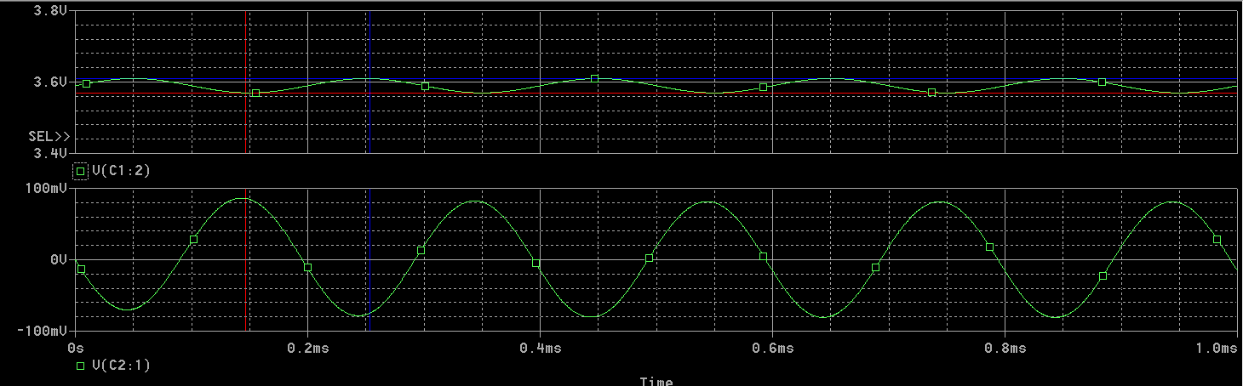

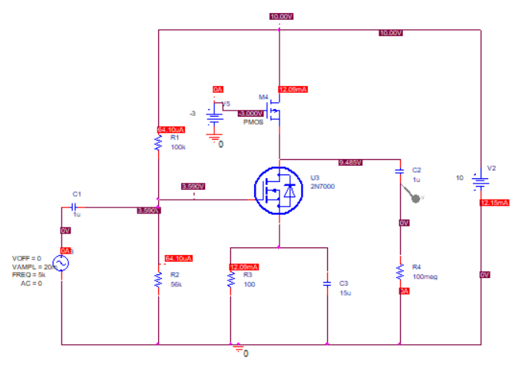
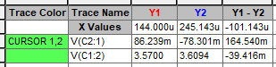

Assessment Rubric
Lab 11
MOSFET Diode and Triode Load
Name: | Student ID:

Points Distribution

Task No. | LR2  Simulation  28 | LR 4  Data Collection  12 | LR 5  Plots  20 | LR 6  Calculation  16 | LR 10  Analysis  20
Task 1 | - | - | - | - | /4
Task 2 | /8 | - | /4 | - | /8
Task 3 | /10 | /4 | /8 | /8 | -
Task 4 | /10 | /8 | /8 | /8 | /8
CLO Mapped | CLO 3 | CLO 1 | CLO 3 | CLO 2 | CLO 1
 | /28 | /12 | /20 | /16 | /20

Affective Domain Rubric |  | Points | CLO Mapped
AR 4 | Report Submission | /4 | CLO 4

CLO – (LDL) | Total Points | Points Obtained
CLO1 – (Psy-3) | 32
CLO2 – (Psy-4) | 16
CLO3 – (Psy-4) | 48
CLO4 – (Aff-3) | 04
Total | 100

For description of different levels of the mapped rubrics, please refer the provided Lab Evaluation Assessment Rubrics and Affective Domain Assessment Rubrics.

